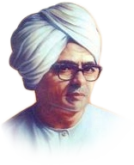

**Shri Shivaji Education Society Amravati’s**

**Shri Shivaji Science & Arts College**

**Chikhli, Dist. Buldana- 443201(MS).**

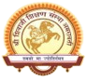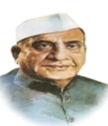

**Department of Physics**

**Report on** Women’s Empowerment workshop on the occasion of International

1. **Title of the Activity: : International Women’s Day**
2. **Date:** 8th March 2020
3. **Chairperson:** Dr. Anil M. Garode, Principal, Shri Shivaji Science & Arts College,Chikhli
4. **Chief Guest/Recourse Person:** Mrs. Varshatai Mendhe, Manager, Bank of Maharashtra AndMrs. Pallavi Palawe, di**rector,**  Seva Sankalp,Ashram Pasalkhed Sapkal
5. **Convenor :** Prof. Shalini A. Katole, Incharge of Women’s Grievance Redressal Cell, Head of the Electronics Department
6. **Co-ordinator :** Dr. Anuradha Muley
7. **Members:** Dr. M. T. Nikam
8. **No of Participants: 106**
9. **The Practice/Activity:**

Dr. Anil M. Garode , Principal , Shri Shivaji Science & Arts College, Chikhli expressed his thought about organization of this workshop and need of knowledge about Historical women’s works in different field.

Dr. V. U. Pochhi, IQAC Co-ordinator and HOD of Botany Department was an inaugurator of this workshop.

Prof. Shalini A. Katole, Head of Electronics Department expressed view about womens Progress in different field & their difficulties in Society.

Mrs. Varsha Mendhe, resource person gave the information about Money transaction in the banking sector likes ATM, RTGS, NEFT, UTR, Smart Card, Credit Card etc. with suitable examples.

Mrs. Pallavi Palawe Director, Seva Sankalp, Ashram, Pasalkhed Sapkal, express her thought about the problems of Orphan in Society. The teaching staff and students were participate in this workshop & their valuable feedback registered.

1. **Evidence of Success/Supporting Documents:**
2. Photographs
3. Newspaper cuttings/Report in Shivdarshan (College Magazine)
4. Participants List
5. **Feedback&Action Taken:**

***Evidence of Success:***

1. ***Newspaper Cuttings/Report in Shivdarshan (College Magazine)***

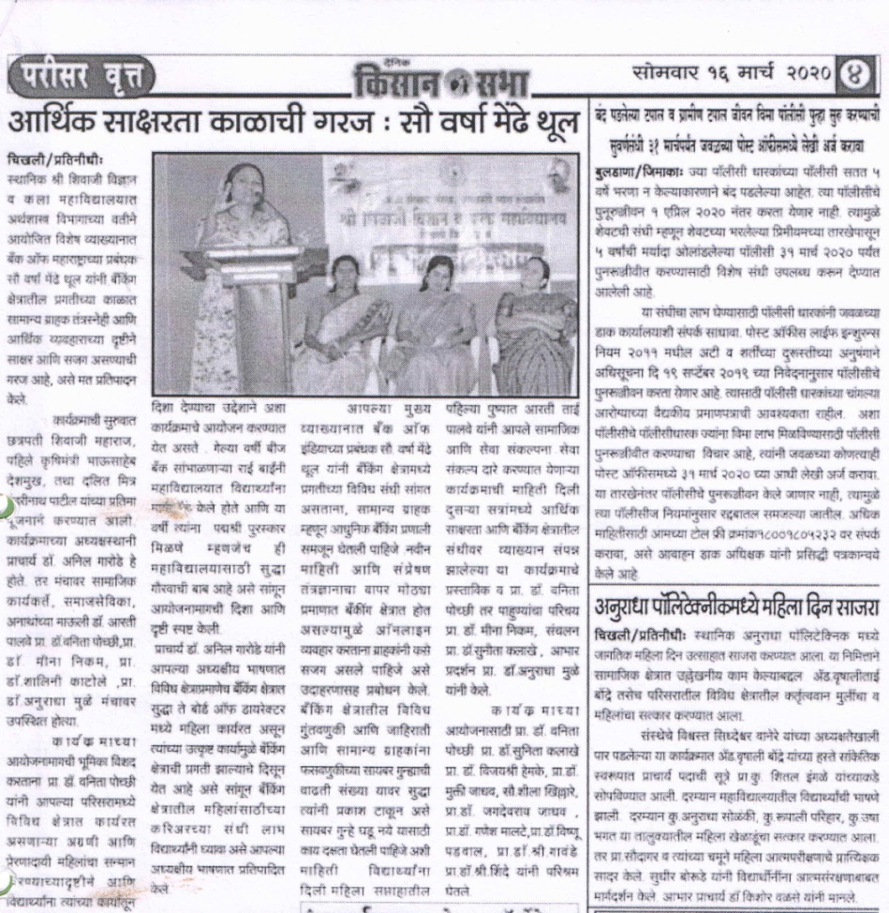

1. ***Photographs***



**Women’s Empowerment workshop on the occasion of International Women’s Day**

**Principal Dr. Anil Garode Address**

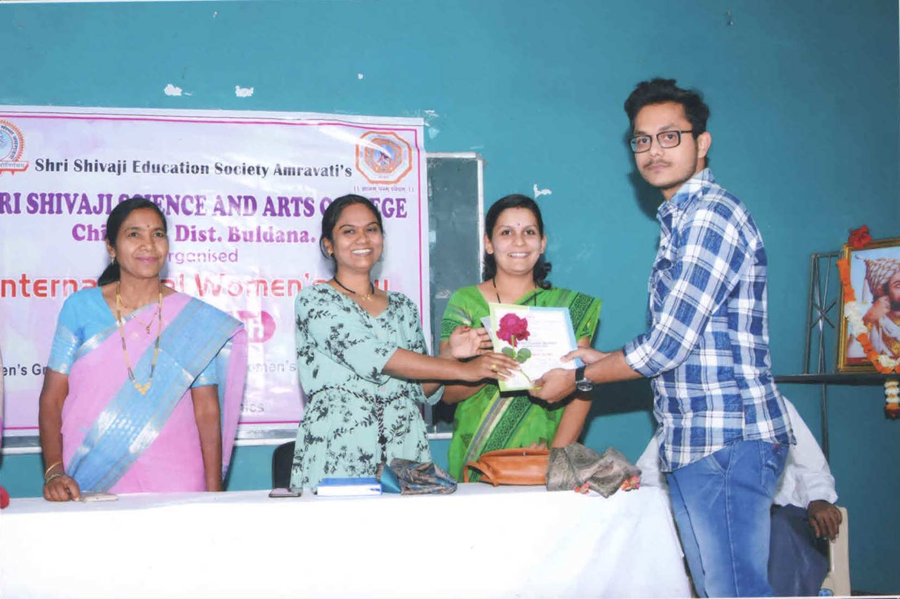

**On the occasion of International Women’s Day**

**Felicitation of winner student by Mrs. Aarti Palwe**

1. ***Participants List***



